**Accelerometer**

How the data looks like in the time domain

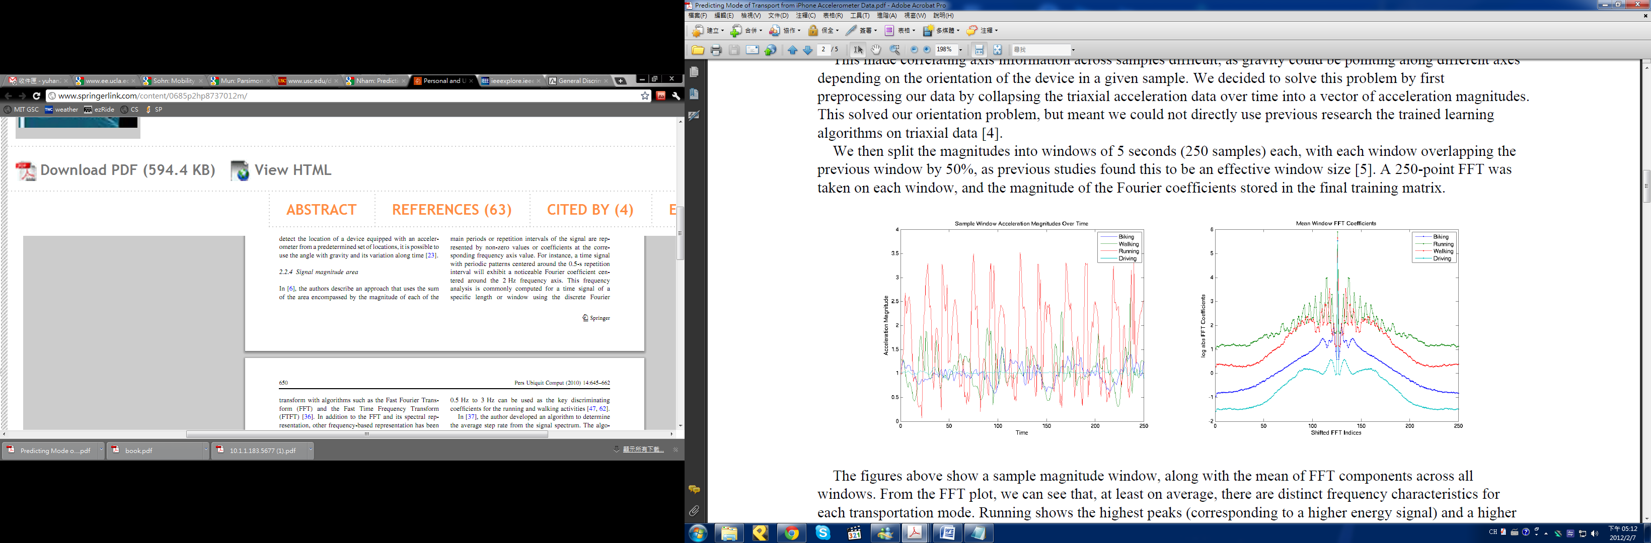

**Accelerometer Features**

Assuming the sampling window has acceleration magnitude {$x_{1},x_{2},…..,x_{N}$}.

And in the frequency domain {$y_{1},y_{2},…..,y_{\frac{N}{2}+1}$}

$f_{i}$ = $a_{i}$ + $b_{i}*i$ f = complex, a = real, b = imaginary

$$y_{i}= 2*\sqrt{a^{2}+ b^{2}}$$

1. **Mean**
$$Mean= \sum_{i=1}^{N}{\frac{x_{i}}{N}}$$

2. **Variance**
$$Mean= \sum_{i=1}^{N}{\frac{{(x}_{i}- Mean)* {(x}_{i}- Mean)}{N-1}}$$

3. **Peak Frequency**
$$Peak Frequency= \begin{matrix}argmax \\ j\end{matrix}\left|y_{i}\right|$$

4. **Peak Power Ratio**
$$Peak Power Energy= \begin{matrix}max \\ j\end{matrix}\left|y_{i}\right|$$

$$Peak Power Ratio= \frac{Peak Power Energy*(\frac{N}{2}+1)}{Total Energy [7]}$$

5. **Curve Length**

This value would be larger if the acceleration magnitude varies tremendously.

$$Curve Length= \sum_{i=2}^{N}{|x_{i-1}-x_{i}|}$$

1. **Averaged Non-linear Energy**

It captures an abrupt change in the activity.

$${NE}_{i}= x_{i}^{2}-x_{i-1}x_{i+1}$$

$$Averaged Non-linear Energy= \sum_{i=2}^{N-1}{\frac{{NE}_{i}}{N-2}}$$

1. **Total Energy**

This captures the intensity of the activity.

$$Total Energy= \sum_{j=1}^{\frac{N}{2}+1}{{y_{j}}^{}}$$

1. **Strength Variation**

When an activity movement is consistent, the pattern of the acceleration magnitude variation should be quite the same, which means that the envelope, or the strength, of the time series would have similar variance. On the contrary, for the activity like running, the acceleration magnitude variation pattern changes from time to time. The corresponding variance of its envelope, then, is more likely to have scattered values. Therefore, we define the Strength Variation as

$$Strength Variation= Var\left(Upper Envelope\right)+ Var\left(Lower Envelope\right)$$

where Var(.) is the variance function. The Upper and Lower Envelope are derived from the samples in the current time-domain sliding window.

1. **Entropy**

This feature helps differentiate between two activities that may have same energy values but different patterns of movement. A nearly uniform movement will have a lower frequency-domain entropy value in comparison to a jerky movement.

$$Entropy= \sum_{j=1}^{\frac{N}{2}+1}{\begin{aligned}c_{j}*\log\left(c_{j}\right)\end{aligned}}$$

Where $c_{j}=\frac{y_{j}}{Total Energy}$